Welcome New User!
Updated 07/01/2023

Welcome to Luma. You will need to access our Luma system for personnel and payroll actions, such as entering your time, reviewing your personal information (W-4, benefits elections, beneficiaries, contact information, direct deposit, job information, emergency contact and much more!) You will also use this system in the future for things like travel reimbursement and managing your purchasing card.

As a new user, you will need to know how to do a few basic actions in the system. Below are the recommended self-paced e-learnings (training that can be accessed at any time) to get you started.

Access e-learning by logging into the SCO Enterprise Dashboard and clicking on the “Luma Training” link (next to the last link)

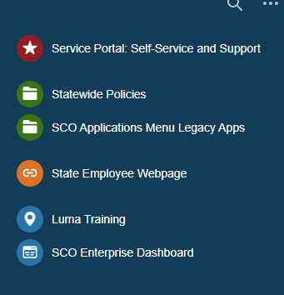

NOTE: E-learnings are an average of 15 minutes each. E-learnings do not have audio.

If the e-learning modules are not on your landing page, you can navigate to them by selecting them from the catalog. Select the Catalog icon….
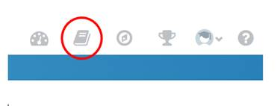
…and then search the training catalog, or review the titles that are offered.
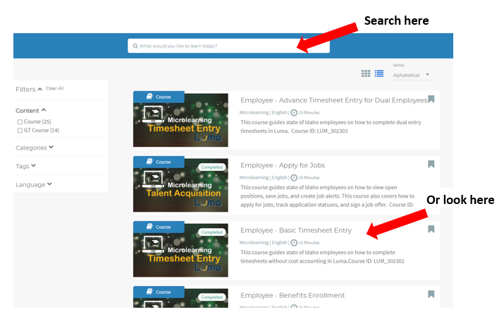

Five Critical e-learnings to take:
- Employee - Basic Timesheet Entry https://idahosco.servicenowservices.com/lms?id=lms_modal_player&registration_id=undefined&registration_id=undefined&course_id=bd03caf21b43a950c53cddb6bc4bcb25
There are several Timesheet Entry trainings. I put the link to the one you will need. You will not need cost accounting on your timesheet. We will do Weekly Timesheets as opposed to Daily Timesheets.
- Employee - Employee Record (how to update your profile)
- Employee - Benefits Enrollment
- Employee - Onboarding and W-4 Tasks
- Employee - Apply for Jobs

Please reach out if you have any difficulties after reviewing these e-learnings.

